# Step 1

1. Connect to your local SQL server database or any SQL database of you choosing.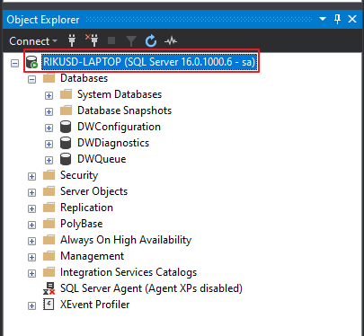
2. Open SQL script inside Step 1 folder called: 1.CREATE DATABASE Northwind.sql  
   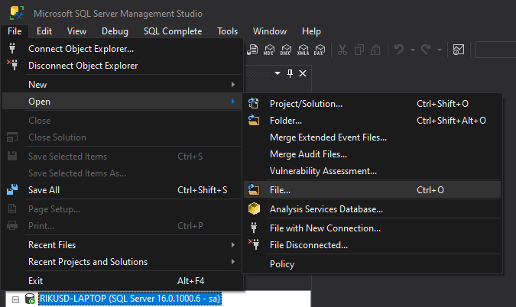  
   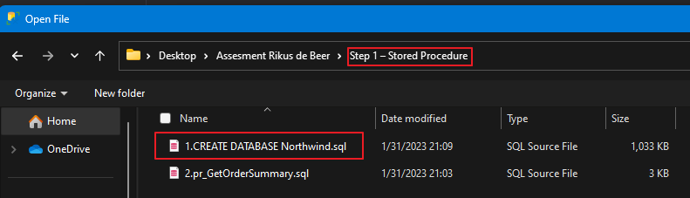
3. Execute the query by clicking on Execute or pressing F5, the database will be created and you will receive a message saying “Commands completed successfully” as indicated in screenshot below  
   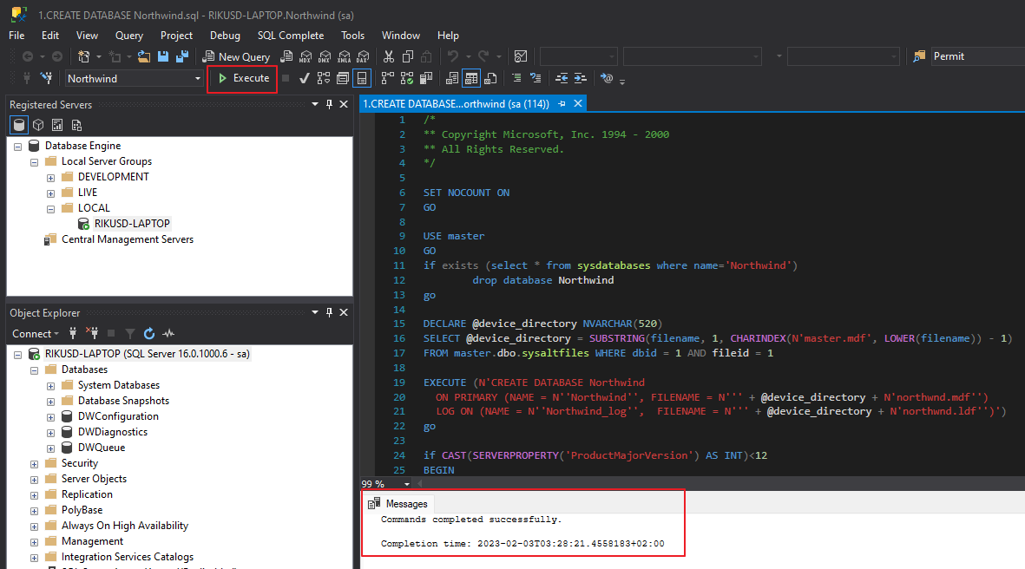
4. Now follow point 2. to open the SQL script called: 2.pr_GetOrderSummary.sql  
     
   A screenshot of a computer

   Description automatically generated
5. Execute the query by clicking on Execute or pressing F5, the database will be created and you will receive a message saying “Commands completed successfully” as indicated in screenshot below.  
   A screenshot of a computer

   Description automatically generated
6. After you have created the stored procedure, you can run the below tests in I new query window by opening a new query window. Right click on Northwind database and click on New Query, see screenshot below  
   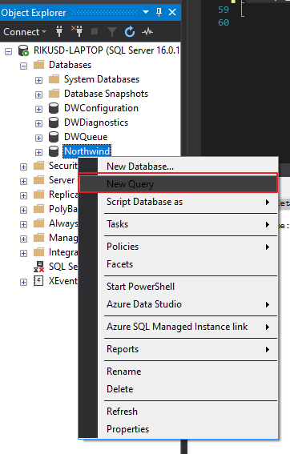  
   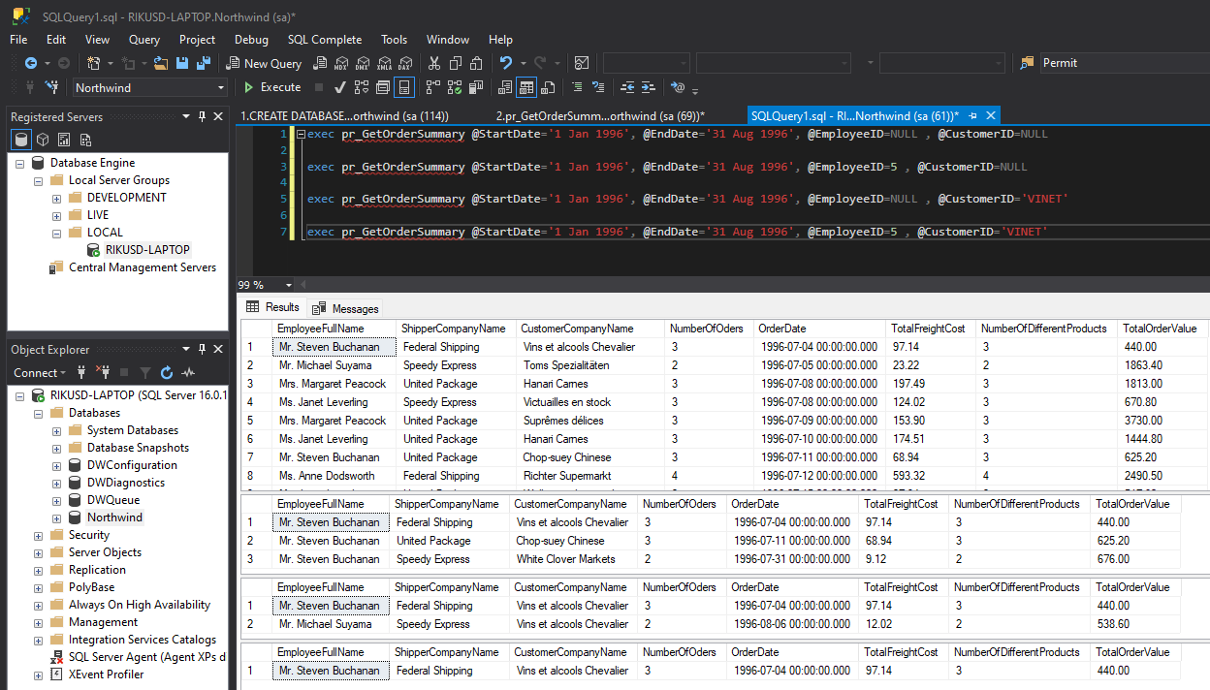
7. Test queries below can be run in new query window by pressing the Execute button or pressing F5

exec pr_GetOrderSummary @StartDate='1 Jan 1996', @EndDate='31 Aug 1996', @EmployeeID=NULL , @CustomerID=NULL

exec pr_GetOrderSummary @StartDate='1 Jan 1996', @EndDate='31 Aug 1996', @EmployeeID=5 , @CustomerID=NULL

exec pr_GetOrderSummary @StartDate='1 Jan 1996', @EndDate='31 Aug 1996', @EmployeeID=NULL , @CustomerID='VINET'

exec pr_GetOrderSummary @StartDate='1 Jan 1996', @EndDate='31 Aug 1996', @EmployeeID=5 , @CustomerID='VINET'

# Step 2

1. Open the API sln by opening the folder Step 2 – Web API/repos/RouletteAPI/RouletteAPI.sln
2. The solution uses .Net 5 , SQLite and Dapper and has JSON return object
3. Run the API by clicking the run button  
   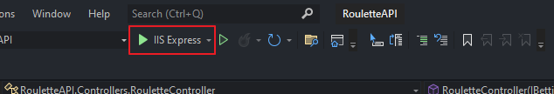
4. The below requests can be used to Place a bet, Spin, View Payout and view the previous spin results.  
   Application

   Description automatically generated with medium confidence
5. You can make requests by clicking on the endpoints and then click on try out, add you values in the Object and press execute.
6. You can also use postman to to send and receive requests.

## Requests:

POST: /Roulette/PlaceCustomerBet

**{**

**"identityNumber": "string",**

**"colourBet": {**

**"black": 0,**

**"red": 0**

**},**

**"partitionBet": {**

**"firstPartition": 0,**

**"secondPartition": 0,**

**"thirdPartition": 0**

**},**

**"evenOddBet": {**

**"evenBet": 0,**

**"oddBet": 0**

**},**

**"halfBet": {**

**"firstHalfBet": 0,**

**"secondHalfBet": 0**

**},**

**"twotoOneBet": {**

**"firstTwotoOne": 0,**

**"secondTwotoOne": 0,**

**"thirdTwotoOne": 0**

**},**

**"numberBets": [**

**{**

**"number": 0,**

**"value": 0,**

**"numberSplit": 0**

**}**

**]**

**}**

GET : /Roulette/Spin

GET: /Roulette/Payout

GET: /History/GetPreviousSpinResult